SIMATS ENGINEERING (SAVEETHA SCHOOL OF ENGINEERING)
Department of Computer Science and Engineering
CO2 ASSESSMENT TOOL 2 – Architecture Design Assignment

Course Code: | CSA10 / CSA1005 | Course Title: | Software Engineering
CO Assessed: | CO2 | Assessment: | Assessment Tool 2 – Architecture Design Assignment
Weightage: | 20% | Total Marks: | 25
CO2 Statement: | Perform detailed requirements analysis, design scalable architectures, and prioritize features with a focus on cross-disciplinary skills
Student Name: | Patteela Yashwanth Kumar | Reg. No.: | 192471055
Date: | 27-10-2026 | Duration: | 60 minutes

Code of Conduct
I Patteela Yashwanth Kumar/ 192471055 (Name / Reg No) certify that this submission is my original work and that I have adhered to the guidelines specified for this assessment. I understand that any violation of academic integrity rules will result in disciplinary action.
Signature of the Student: Patteela Yashwanth Kumar
Annexure A – Architecture Design Assignment
Instructions to Students:
Each student will be assigned an individual software project problem statement. Based on the assigned problem, analyze the system requirements and design an appropriate software architecture by applying software engineering principles. Your submission should demonstrate your ability to select, justify, and evaluate a suitable architectural style.

Question
Based on your assigned problem statement, perform an Architecture Design Analysis and prepare an architecture design report by answering the following questions:
- Analyze System Requirements
- Study the given problem statement and identify the system objectives.
- Analyze the functional and non-functional requirements that influence the software architecture.
- Identify key quality attributes such as scalability, maintainability, reliability, availability, performance, and security.
- Select a Suitable Software Architecture
- Select an appropriate architectural style for the proposed system (e.g., Layered Architecture, Client-Server, MVC, Microservices, Event-Driven, Service-Oriented Architecture, Serverless, or Hybrid Architecture).
- Justify why the selected architecture is the most suitable for the given problem.
- Draw the Software Architecture Diagram
- Design a clear architecture diagram illustrating the overall structure of the proposed system.
- Include all major layers/components, databases, external systems, APIs, and communication mechanisms.
- Use appropriate software architecture notations and labels.
- Explain Components and Their Interactions
- Describe the purpose and responsibilities of each architectural component.
- Explain how the components communicate and exchange data.
- Illustrate the overall workflow of the system.
- Discuss Quality Attributes
Evaluate how the proposed architecture addresses the following aspects:
- Scalability
- Security
- Performance
- Reliability
- Maintainability
- Availability
- Justify Architectural Decisions
- Explain the rationale behind your architectural choices.
- Discuss the trade-offs considered while selecting the architecture.
- Explain how the chosen architecture supports future enhancements, system integration, and long-term maintainability.
Rubrics for Calculation
Evaluation Criteria | Excellent (4 Marks) | Good (3 Marks) | Satisfactory (2 Marks) | Needs Improvement (1 Mark)
System Requirement Analysis (30%) | Thoroughly analyzes the problem statement, accurately identifies functional and non-functional requirements, and clearly explains quality attributes influencing the architecture. | Analyzes most requirements with minor omissions or limited explanation. | Identifies only basic requirements with partial analysis. | Requirement analysis is incomplete, inaccurate, or lacks clarity.
Selection of Software Architecture (25%) | Selects the most appropriate architectural style with strong technical justification aligned to system requirements. | Selects a suitable architecture with reasonable justification. | Architecture is partially suitable with limited justification. | Inappropriate architecture selected or justification is missing.
Architecture Diagram and Component Design (20%) | Produces a clear, complete, and well-structured architecture diagram with all major components, interfaces, and interactions accurately represented. | Diagram is mostly complete with minor omissions or notation issues. | Diagram includes only essential components and lacks sufficient detail. | Diagram is incomplete, unclear, or technically incorrect.
Component Interaction and Quality Attribute Analysis (15%) | Clearly explains component responsibilities, interactions, and thoroughly discusses scalability, security, performance, reliability, maintainability, and availability. | Explains most components and quality attributes with minor gaps. | Provides limited explanation of interactions and addresses only some quality attributes. | Component interactions and quality attributes are poorly explained or missing.
Architectural Justification and Technical Presentation (10%) | Provides strong justification for architectural decisions, discusses trade-offs and future enhancements, and presents a well-organized, professional report. | Provides adequate justification with minor gaps; report is well organized. | Limited justification with minimal discussion of trade-offs or future scope; report needs improvement. | Justification is weak or absent; report lacks organization and technical clarity.

Criteria | Mark
System Requirement Analysis (30%) | /5
Selection of Software Architecture (25%) | /5
Architecture Diagram and Component Design (20%) | /5
Component Interaction and Quality Attribute Analysis (15%) | /5
Architectural Justification and Technical Presentation (10%) | /5
TOTAL | /25

Architecture Design Report:
Smart Donation and Charity Management Platform
1. Analysis of System Requirements
The Smart Donation and Charity Management Platform serves donors, NGOs, beneficiaries and volunteers. Money is handled, so the system must be trustworthy, secure and always available, and it must cope with sudden donation peaks during festivals, disasters and fundraising drives. These needs shape the choice of architecture in the following sections.
System objectives
- Provide a secure online platform where donors give money, goods or time to verified charity campaigns.
- Make every donation traceable from payment to final utilization, so that donors trust the system.
- Automate campaign management, beneficiary verification, fund allocation, receipts, notifications and reporting.
- Support future growth in users, campaigns and integrations without redesigning the system.
Requirements that influence the architecture
- Functional: online and recurring donations, payment gateway integration, receipts, campaign and beneficiary management, volunteer registration, impact tracking, notifications and reports. Payment, notification and reporting are different in load and failure behavior, so they need separation.
- Non-functional: handling 5,000 concurrent users, page load within 3 seconds, 99.5 percent availability, encryption and role-based access, no loss of confirmed transactions, and easy maintenance.
- Data consistency: Donation, payment and receipt generation must be consistent and never lost, so a transactional database and reliable messaging are required.
- Integration: Payment gateway, SMS, email and cloud storage must be replaceable without changing the core logic, so loose coupling and well-defined interfaces are required.
Key quality attributes (Table 1)
Attribute | Target | Architectural Driver
Scalability | Handle festival and disaster-relief spikes | Stateless services, load balancer, independent scaling of Donation and Payment services
Security | Protect money and personal data | API gateway authentication, JWT/OAuth2, TLS, PCI-DSS compliant gateway
Performance | Response within 3 seconds | Redis cache, asynchronous events, database indexing
Reliability | No lost transactions | ACID database, message queue with retry, idempotent payment handling
Maintainability | Easy change and testing | Layered separation, small services, documented APIs
Availability | 99.5 percent uptime | Redundant instances, health checks, database replication and backups
2. Selection of a Suitable Software Architecture
Selected architecture: Hybrid Architecture combining a Layered (N-tier) structure, a Microservices-based business layer and an Event-Driven communication mechanism, accessed through an API Gateway in a client-server model.
Style (Table 2) | Advantage | Limitation for this system
Layered / Monolith | Simple, quick to build | Whole system scales together; one failure affects all
MVC | Clean UI separation | Only structures one application, not the whole platform
Microservices | Independent scaling and deployment | More complex operation and testing
Event-Driven | Loose coupling, asynchronous work | Harder debugging if used alone
Serverless | No server management | Cold starts and vendor dependence for payments
Hybrid (selected) | Combines structure, scalability and loose coupling | Needs careful design and DevOps support
A single monolithic layered application would be easy to build but would fail the scalability and availability goals, while a pure microservice or serverless design would add more cost and complexity than a student-level or small-NGO deployment can manage. The hybrid style keeps the clear structure of layers and uses microservices only where independent scaling and fault isolation matter, such as donation, payment and notification.
Justification:
- Donation traffic is uneven; the Donation and Payment services can scale alone during campaigns without scaling the whole system.
- The layered structure keeps presentation, business logic and data separate, which makes the platform easy to understand and secure.
- Events (such as DonationCompleted) let receipts, notifications and reports run in the background without slowing the donor.
- A fault in one service, such as Reporting, does not stop donations, which protects reliability and trust.
- Each service can use the best technology and be developed by a separate team, which supports faster delivery and future enhancement.
- The architecture matches the requirements: security at the gateway, consistency in the database and flexibility through events.
3. Software Architecture Diagram
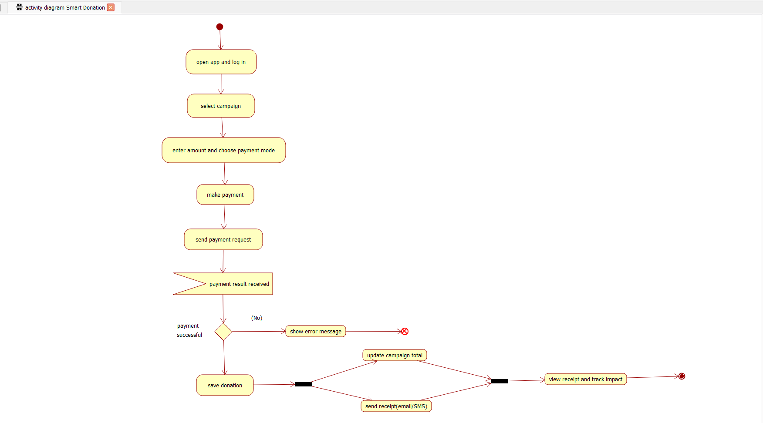

Figure 1: Architecture (Activity Diagram)of the Smart Donation and Charity Management Platform
Proposed technology stack: React and a cross-platform mobile framework for clients; Spring Boot or Node.js for services; PostgreSQL, Redis and an object store for data; RabbitMQ or Kafka as the broker; Docker and Kubernetes for deployment; JWT and OAuth2 for security.
Notation: rectangles are components, dashed rectangles are layers or tiers, arrows show the direction of communication, and labels on arrows give the protocol (REST/HTTPS, SQL, API, webhook).
4. Components and Their Interactions
4.1 Component responsibilities (Table 3)
Component | Purpose and Responsibility
Web, Mobile and Admin clients | User interfaces for donors, beneficiaries, volunteers and administrators (React web, mobile app, admin dashboard).
API Gateway + Load Balancer | Single entry point; routes requests, checks tokens, limits request rate and distributes traffic.
User & Auth Service | Registration, login, roles and permissions, token issue.
Campaign Service | Create, approve, update and close campaigns; maintain raised amounts.
Donation Service | Record one-time, recurring and in-kind donations; generate receipts.
Payment Service | Talk to the payment gateway, verify payment status, handle refunds.
Beneficiary & Aid Service | Aid applications, document upload, verification and fund allocation.
Volunteer Service | Volunteer registration, events and hour logging.
Reporting & Analytics Service | Financial, donor and impact reports and dashboards.
Notification Service | Email, SMS and in-app alerts through external providers.
Message Broker | Delivers events between services asynchronously with retry.
Data layer | PostgreSQL for transactions, Redis for caching, object store for documents and receipts, audit store for logs.
4.2 Communication and data exchange
- clients to gateway and gateway to services use REST over HTTPS with JSON data.
- services publish and consume events through the message broker, so they stay loosely coupled.
- services access their own database through SQL/ORM; frequently read data is cached in Redis.
- external systems (payment gateway, SMS and email) are called through secure APIs, and the payment result returns by webhook.
- Data integrity: sensitive requests such as payments use idempotency keys, so repeated clicks or network retries do not charge a donor twice.
- Monitoring: every service writes logs and metrics to a central monitoring tool, which helps administrators trace a request through the system.
4.3 Overall workflow (donation)
- Step 1: Donor opens the web or mobile app, logs in and selects a campaign.
- Step 2: Gateway validates the token and forwards the request to the Donation Service.
- Step 3: Donation Service asks the Payment Service, which redirects the donor to the payment gateway.
- Step 4: The gateway confirms payment by webhook; the donation is saved in the database.
- Step 5: A DonationCompleted event is published; Notification Service sends the receipt, Campaign Service updates the total and Reporting Service updates dashboards.
- Step 6: Donor tracks the usage of the money as the Beneficiary & Aid Service records allocation.
Aid workflow: a beneficiary submits an application through the Beneficiary & Aid Service; the NGO administrator verifies it from the dashboard; approval raises an AidApproved event, the allocation is recorded against the campaign, and the Notification Service informs the beneficiary and the donors of the campaign.
4.4 Deployment view
- Edge: static files and images are served through a content delivery network close to the user.
- Entry: a load balancer and the API Gateway run in at least two instances in different availability zones.
- Application: each microservice runs as a Docker container managed by Kubernetes, which handles scaling, restart and rolling updates.
- Data: a managed PostgreSQL cluster with a standby replica, Redis cache and replicated object storage.
- Delivery: a CI/CD pipeline builds, tests and deploys each service automatically, so changes reach users quickly and safely.

5. Quality Attribute Discussion
- Scalability: each microservice runs in containers and scales horizontally behind the load balancer; the database uses read replicas and caching for heavy read traffic. During a peak campaign, extra Donation and Payment instances start automatically while less used services stay small.
- Security: HTTPS everywhere, token-based authentication at the gateway, role-based authorization, encrypted data, no card data stored locally and a complete audit trail. Input validation protects against SQL injection and cross-site scripting, and administrators use two-factor authentication.
- Performance: Redis caching of campaign lists, asynchronous event processing, indexed queries and a content delivery network for static files keep response time under 3 seconds. Heavy work such as report generation and email sending is moved off the main request path.
- Reliability: ACID transactions, idempotent payment handling, message retry, and failure isolation between services prevent loss of donations. If the notification provider is down, events wait in the queue and are delivered later.
- Maintainability: small, well-defined services with clear APIs can be changed, tested and deployed independently, and the layered design limits the effect of changes. Version-controlled APIs let old and new clients work together during upgrades.
- Availability: multiple service instances, health checks with automatic restart, database replication, daily backups and failover give 99.5 percent uptime. Deployment across more than one availability zone protects against a data centre failure.
In summary, the selected architecture satisfies all six quality attributes: it scales with demand, protects data, responds quickly, avoids loss of transactions, can be changed easily and stays available during failures.
6. Justification of Architectural Decisions
Decision (Table 4) | Rationale | Trade-off
Microservices for business layer | Independent scaling and fault isolation | More deployment and monitoring effort
API Gateway | Central security and routing | Extra component that must itself be redundant
Event bus for notifications | Fast response, loose coupling | Eventual consistency and harder tracing
Relational database | Strong consistency for money | Harder to scale writes than NoSQL
External payment gateway | Avoids storing card data, meets PCI-DSS | Dependency on a third party
Trade-offs considered:
- microservices give independent scaling but need more infrastructure, monitoring and skilled staff than a monolith.
- asynchronous events give speed and loose coupling but make some data eventually consistent; critical payment data therefore stays in a strongly consistent transactional database.
- using an external payment gateway reduces security risk and effort but creates dependence on a provider; this is reduced by an adapter interface that allows another gateway to be plugged in.
- caching improves speed but needs rules for expiry so that donors never see wrong campaign totals.
Rationale summary: the main architectural decisions were driven by three priorities: protecting money and personal data, staying available during donation peaks, and allowing the platform to grow. Alternatives such as a pure monolith were rejected because one failure or one traffic peak would affect every user, and a fully serverless design was rejected because of dependence on one vendor and unpredictable delays for payment confirmation.
Future enhancements and integration: new services such as an AI-based fraud detection service, a recommendation engine, a blockchain-based transparency ledger, or integration with government and bank systems can be added as separate services behind the gateway without changing existing ones. Open REST APIs and standard events make integration with NGO partners, accounting software and mobile wallets straightforward.
Long-term maintainability: clear layers, documented interfaces, automated testing, containerized deployment (Docker and Kubernetes) and centralized logging allow the platform to evolve over many years with low risk and low cost. The extra complexity of the hybrid design is accepted because it provides the scalability, reliability and trust that a donation platform requires.

